Kindergarten and Grade 1 Zoo Field trip Itinerary
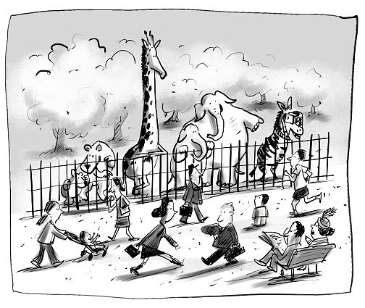
- Bus leaves the school at 9:00 a.m.
- Arrive at the zoo at approximately 9:45 a.m. We will be arriving at the North Gate. Volunteers that are not on the bus, please meet us there. We will go through the gate as one group.
- We will separate into small groups led by one adult. At this time, groups will be allowed to explore the zoo for 1 hour. Please remember to stay together as a small group!
- We will meet for lunch at 11:15 a.m.
  - If it rains: We will meet by the cafeteria and eat our lunch inside.
  - If it is not raining: we will meet on the grass by the conservatory (Butterfly house).
- After lunch, we will walk as a whole group to the Savanah classroom.
- After lunch, your small group is free to continue exploring the zoo until 1:30pm.
- We will meet at the penguin house at 1:30. The bus will be arriving at 2:00 p.m.
- We will arrive back at Carseland School by 3:00 p.m.

Tips for a great Day!
Please Do’:
- Bring appropriate clothing. Please check the weather to see if rain gear will be needed.
- Put sunscreen on your child before school.
- Dress in your school t-shirt.
- Bring and easy to eat bag lunch. Please have all items disposable so your child will not have to carry their lunch bag.
- Talk to you child about staying safe. We will be using washroom in buddies so that children are not left alone.
- Have lots of fun!!!!
Please do not
- Send money with your child. They will not have a chance to buy any food and we will not be visiting the gift store.

If there are any emergencies while we are away, please contact the school, and they will make arrangements.
Thank you!
Miss Laura and Mrs. Lazaruk

